Automated Web Application Deployment Using Jenkins, GitHub, and Apache (httpd) on AWS

- Fist launch instance and configure a security group
- Installation of java and httpd on your server
- Integration of git on your servers
- Create job
- Run Script
1. Fist launch instance and configure a security group
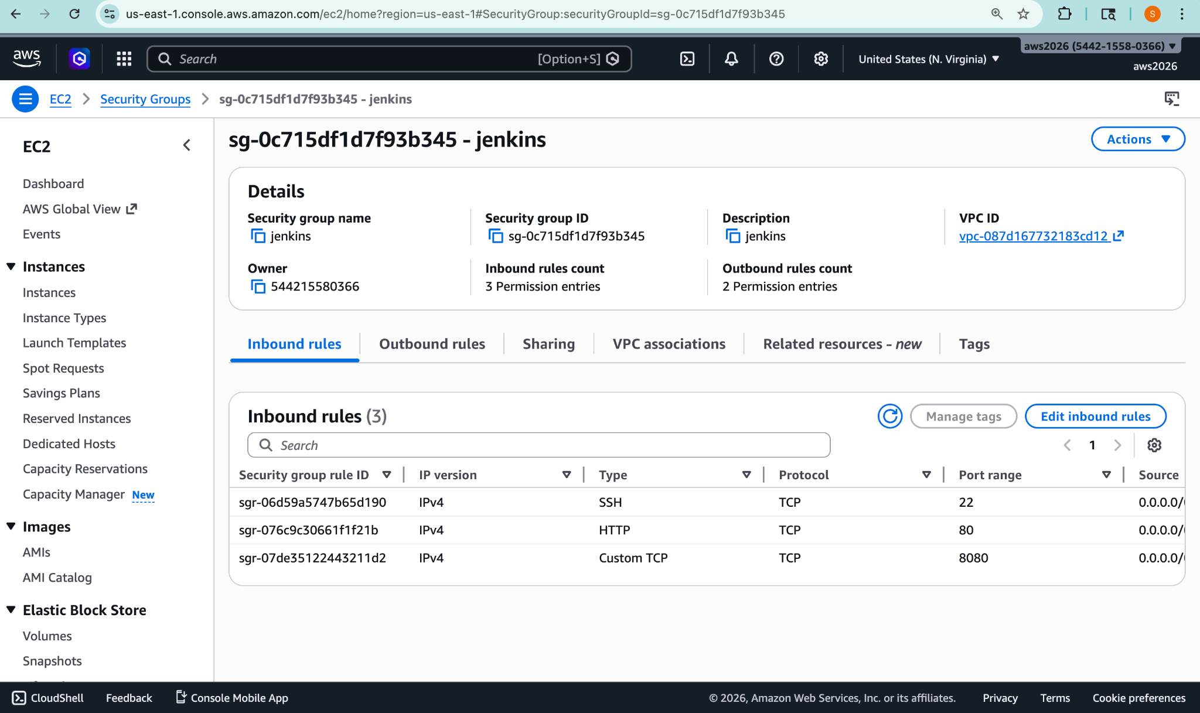
2 . Installation of java and httpd on your server
3. Integration of git on your servers

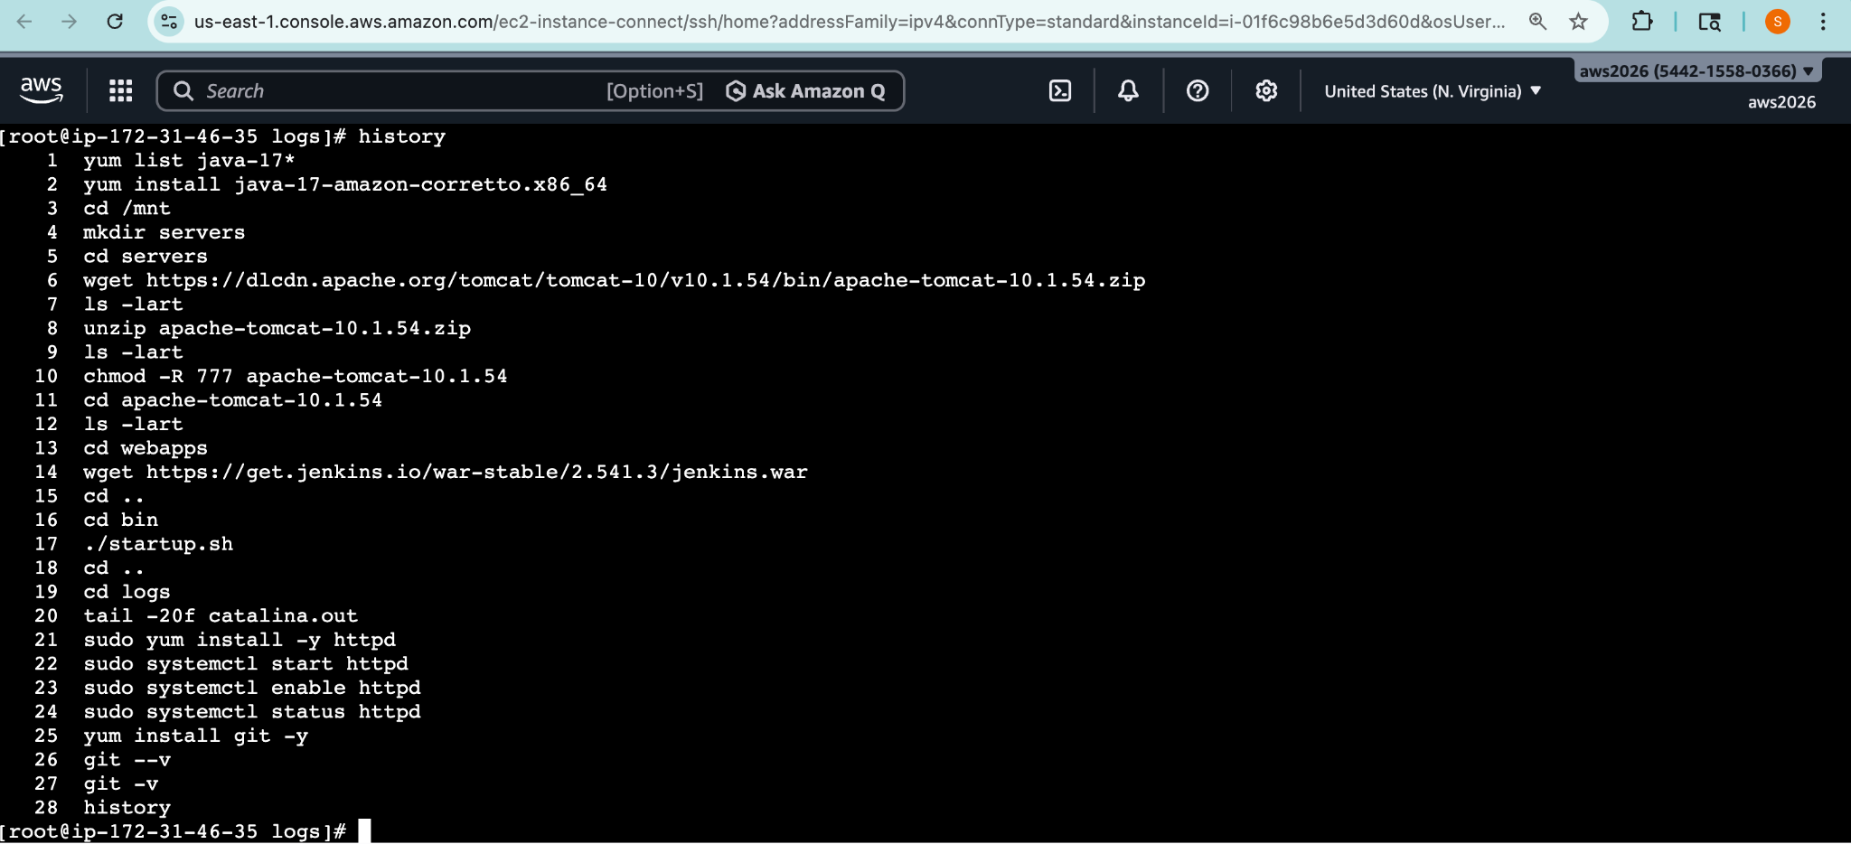
4. Create job
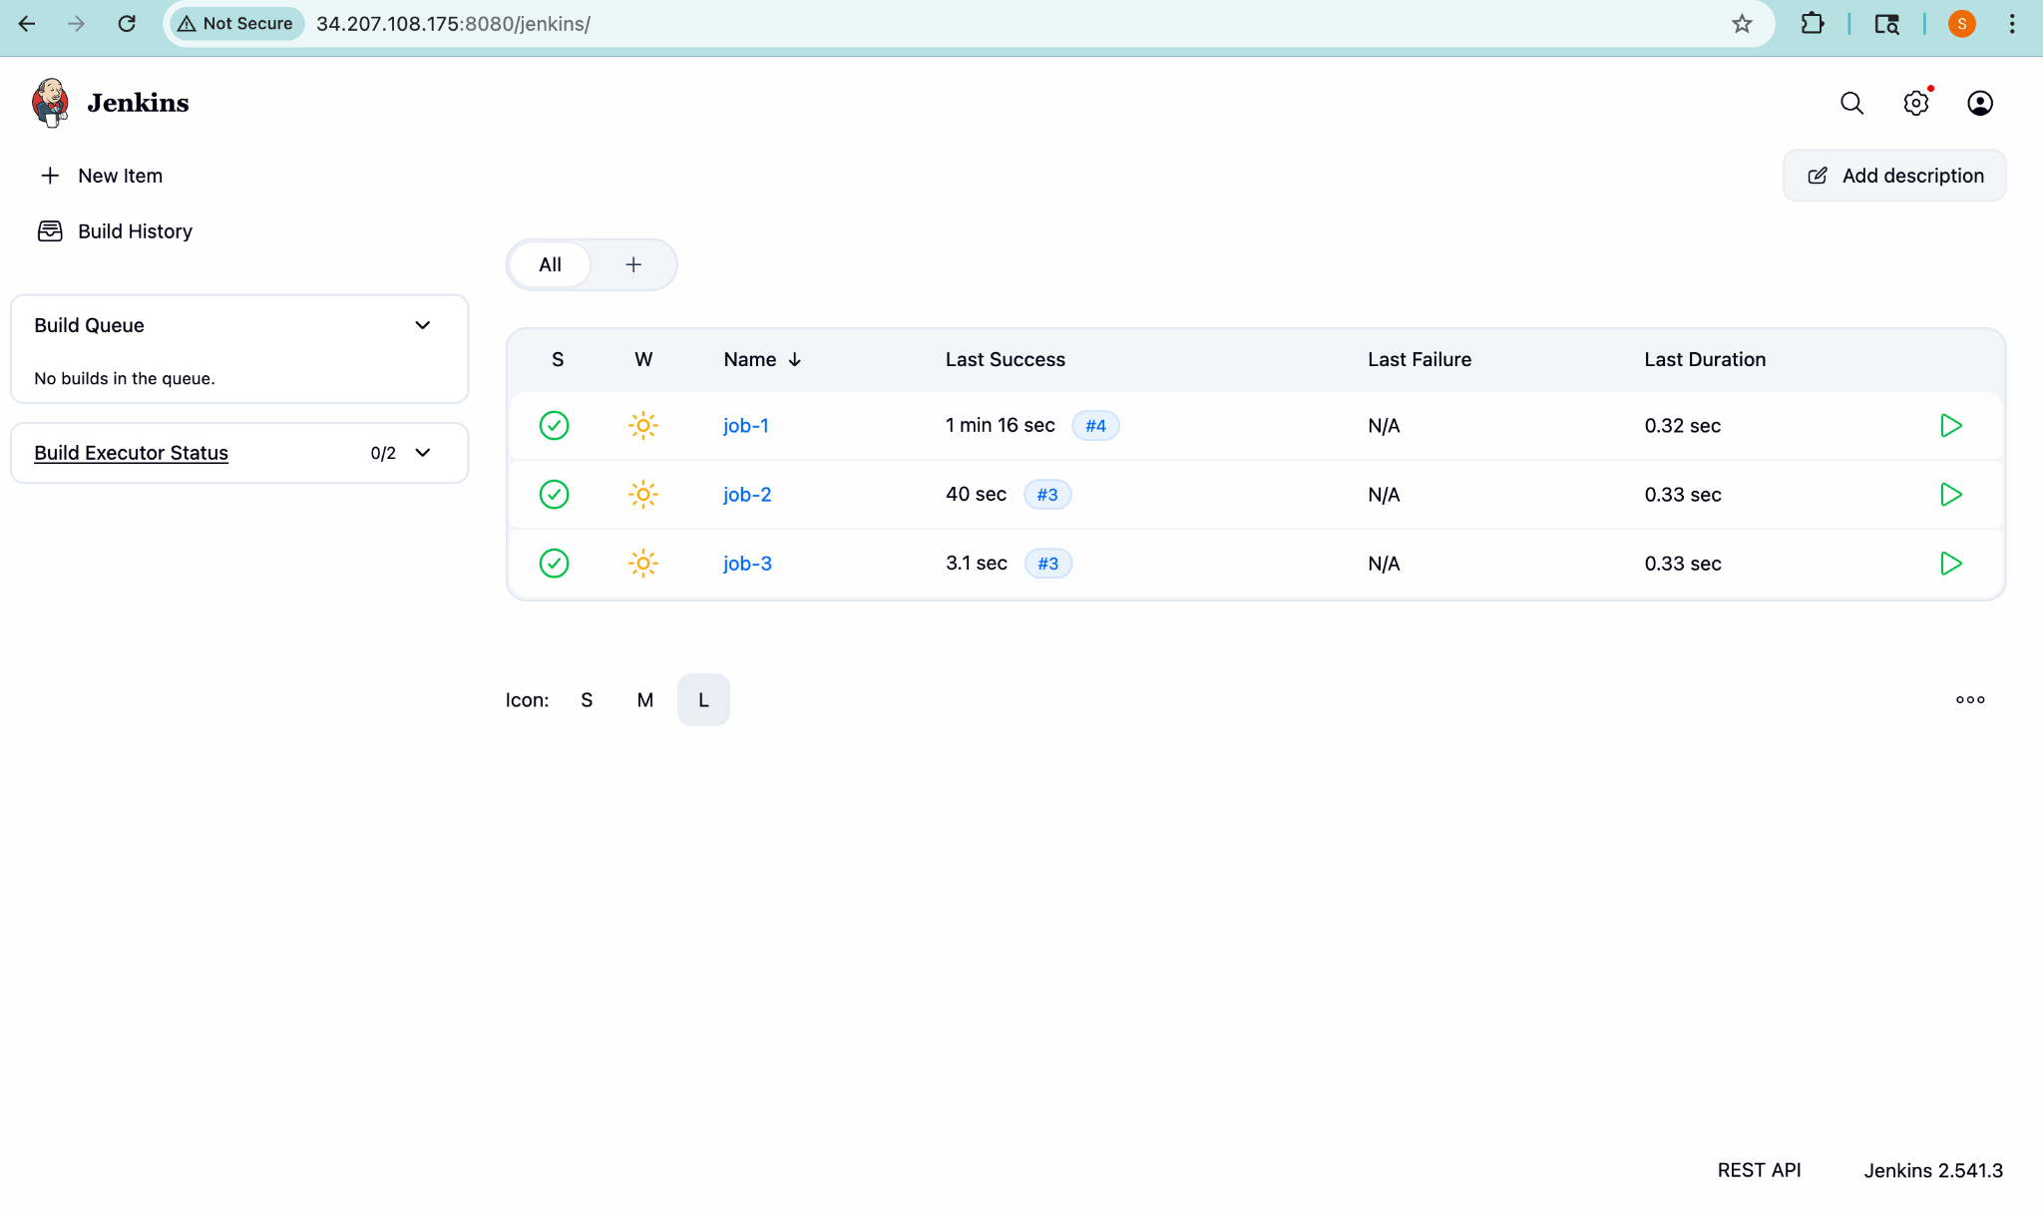

5. RUN Script
#!/bin/bash
set -e

echo "Running Job 1"

# Clean old files
sudo rm -rf /var/www/html/*

# Copy new file
sudo cp index.html /var/www/html/

# Fix permissions (VERY IMPORTANT)
sudo chown -R apache:apache /var/www/html
sudo chmod -R 755 /var/www/html

echo "Job 1 Deployment Done"

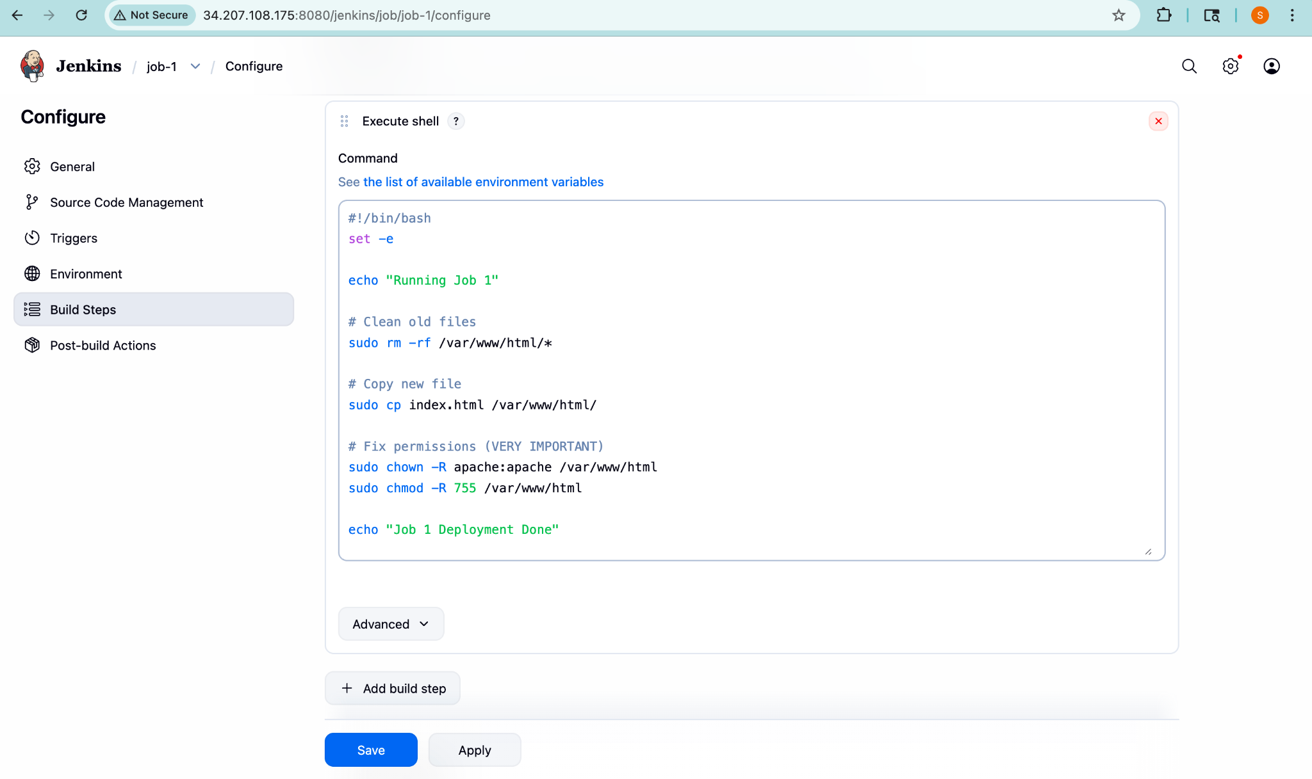

#!/bin/bash
set -e

echo "Running Job 2"

# Clean old deployment
sudo rm -rf /var/www/html/*

# Deploy new file
sudo cp index.html /var/www/html/

# Fix permissions (IMPORTANT)
sudo chown -R apache:apache /var/www/html
sudo chmod -R 755 /var/www/html

echo "Job 2 Deployment Done"

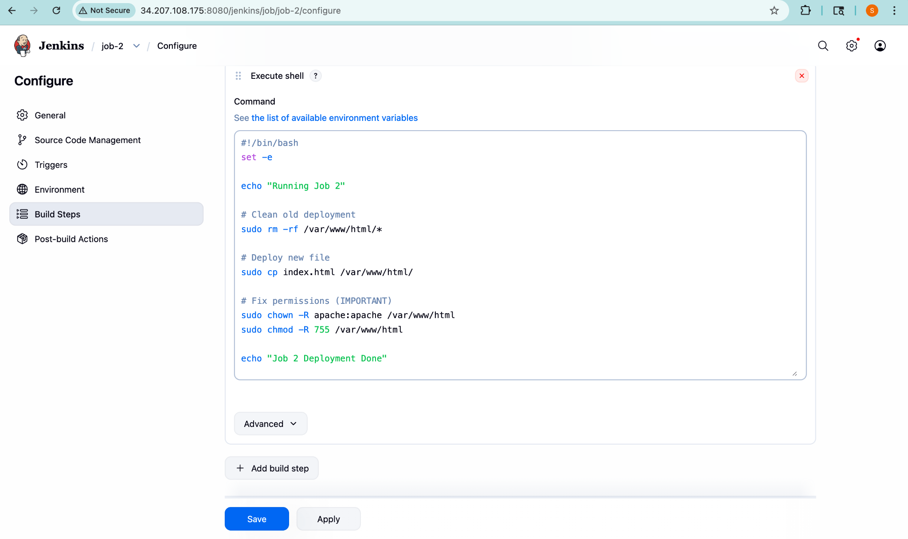

#!/bin/bash
set -e

echo "Running Job 3"

# Clean old deployment
sudo rm -rf /var/www/html/*

# Deploy new file
sudo cp index.html /var/www/html/

# Fix permissions (IMPORTANT)
sudo chown -R apache:apache /var/www/html
sudo chmod -R 755 /var/www/html

echo "Job 3 Deployment Done"
